Name: Sai Rohit Kalyan Gandham

UTA ID: 1002070724

Emailed: [sxg0724@mavs.uta.edu](mailto:sxg0724@mavs.uta.edu)

1Q)

1. What do you observe from the two figures generated by line 7 and line 9 in ftt_test.m? Explaining what happened. (15 pt)

Sol)

FileName: ftt_test.m

1. function fft_test()

2. freq = 200;

3. sampleRate = 1000;

4. time_ticks = 0:1/sampleRate:1;

5. realSignal = sin(2*pi*freq*time_ticks);

6. figure; plot(realSignal);

7. plot_fft(realSignal, sampleRate);

8. complexSignal = exp(j*2*pi*freq*time_ticks);

9. plot_fft(complexSignal, sampleRate);

10. end

In line No: 7 : we see plot_fft(realSignal, sampleRate)

We are plotting a graph of the fft(Fast Fourier Transformation) of the parameter realSignal which is nothing but the sine function. And on the X-axis we are comparing it with a frequency of 200Hz and amplitude of 1.

Using Euler’s Formula

We know that

1. ejft = cos(x) + j . sin(x)
2. e-jft = cos(x) – j . sin(x)

With the above two formulas we get plots on both sides of the Spectrum Where the amplitude is half of the amplitude of the original Signal.

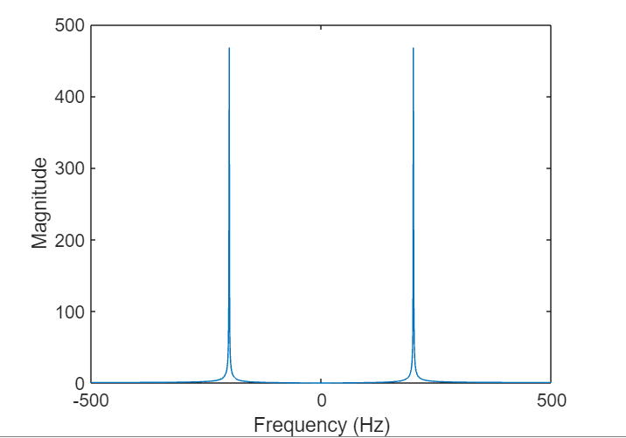

And in Line No: 9: we see a plot_fft(complexSignal, sampleRate)

Here the complex exponential signals with a frequency of 200 Hz is unique so that it will only consider the ejft = cos(x) + j . sin(x).

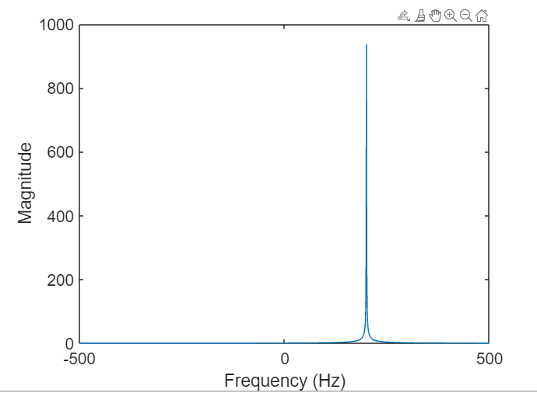Therefore we are getting the plot only in right(positive) side of the spectrum at the x-axis of 200 Hz.

b. What do lines 6, 7 and 8 in plot_fft.m perform? (15 pt).

Sol)

FileName: plot_fft.m

1. function plot_fft(data, sampleRate)

2. fftCoeff = fftshift(fft(data));

3. mag = abs(fftCoeff);

4. N = length(data);

%freqList = (-N/2:N/2-1)*(sampleRate/N)

% calculate frequency spacing

5. df = sampleRate / N;

6. f = (0:(N-1))*df;

7. f(f >= sampleRate/2) = f(f >= sampleRate/2) - sampleRate;

8. freqList = fftshift(f);

9. figure;

10. plot(freqList, mag);

11. xlabel('Frequency (Hz)');

12. ylabel('Magnitude');

13. set(gca, 'FontSize', 15);

14.end

In Line No: 6: f = (0:(N-1))*df;

We are constructing a one dimensional(1-D array/ Matrix ) view of frequency significances from

Zero(0) to N-1 with space gap of the 1 df Hz.

Here df = sampleRate/ N

sampleRate = 1000;

N = len(data) which is nothing but the realSignal = sin(2*pi*freq*time_ticks);

Or the complexSignal = exp(j*2*pi*freq*time_ticks);

And we get sampleRate from fft_test file the values are

We use this value for as a matrix to plot.

In Line No: 7: f(f >= sampleRate/2) = f(f >= sampleRate/2) - sampleRate;

Once we have the values of the f and sampleRate, we are doing a subtraction operation of the frequency significances that is more than the selection of sampleRate/ 2 with a simple rate.

This will create an array of values wit both Positive and negative frequency values.

In line No: 8: freqList = fftshift(f);

The fftshift(f) function  rearranges a Fourier transform X by shifting the zero-frequency component to the center of the array.

As per the definition we are moving the frequency significances which means we do have the both the positive and negative.

So the positive values all are going to be right side of the plot and all the negative are going to be left side.

Finally from -sampleRate/2 to +sampleRate/2 for plotting the spectrum.

c. What is the maximum value of “freq” in ftt_test.m (line 2) that you can change (other variables are remaining the same)? Why? (10 pt)

Sol)

The sampleRate is 1000.

So the maximum frequency will be sampleRate/2.

so the maximum frequency will be 500 Hz.

We must examine the minimum sample rate since it has a maximum frequency that is two times as high as the minimum sample rate, which is merely a component of it.

2Q)

1. Explain what sampleRate (line 1) and sampleTimes (line 2) mean to the signal (15 pt).

Sol)

FileName: spectrogram.m

%Read the samples from the audio file

1. [inputSound, sampleRate]=audioread('RohitAudio.m4a');

2. sampleTimes = (1:length(inputSound))*(1/sampleRate);

%Play sound

3. sound(inputSound, sampleRate);

%Plot the sound

4. figure;

5. plot(sampleTimes, inputSound);

6. ax = gca;

7. F_size = 20;

8. ax.FontSize = F_size;

9. xlabel('Time (sec)', 'FontSize', F_size);

10. ylabel('Amplitude', 'FontSize', F_size);

%Plot spectrogram

11. Window = 1000;

12. Overlap = 900;

13. NumFFT = 5000;

14. figure; spectrogram(inputSound, Window, Overlap, NumFFT, sampleRate, 'yaxis');

15. ax = gca;

16. F_size = 20;

17. ax.FontSize = F_size;

18. xlabel('Time (sec)', 'FontSize', F_size);

19. ylabel('Frequency (kHz)', 'FontSize', F_size);

In Line No: 1: [inputSound, sampleRate]=audioread('RohitAudio.m4a');

The parameter “inputSound” will take a single Column or Row are a matrix of one dimensions

“sampleRate” it takes a integer value of in my code is 4800

It will read the audio file and convert them in to array which will take as the inputSound, SampleRate.

In Line No: 2: sampleTimes = (1:length(inputSound))*(1/sampleRate);

In line number 2 we will take the sampleTimes by the 1:length(inputSound))*(1/sampleRate)

This value rate will give us the period between individually sample.

Finally, we are rendering the instant of time for every sample recorded.

b. Record your own voice saying “Networking UTA 2022” and save it into an audio file that can be read by Matlab (e.g., hw1.m4a or hw1.wma). Modify and run the above code on the collected audio file (hw1.m4a or hw1.wma) with Window = 1500 and Window = 3200 (line 12), describing what you observe from the spectrogram outputs. Submitting the output figures. (15 pt)

Sol)

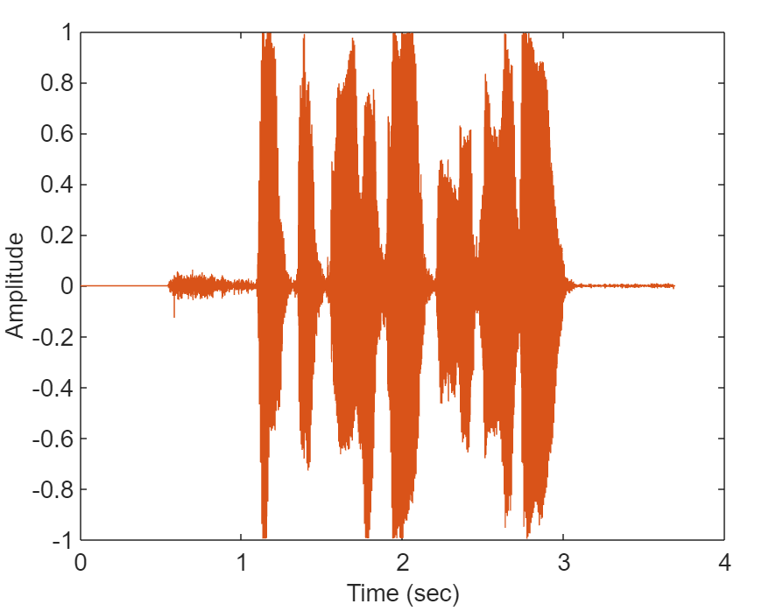The Window Size = 1500

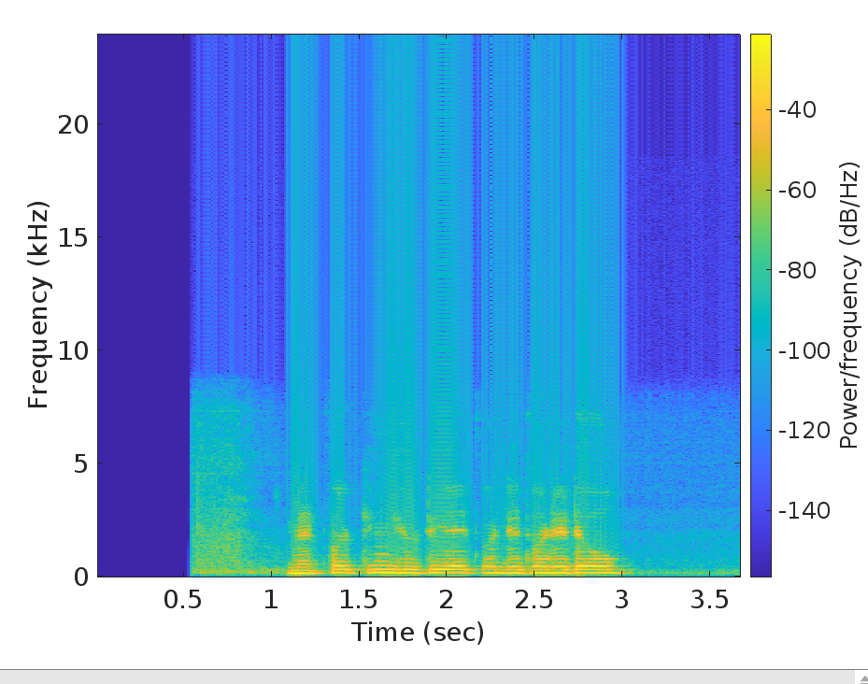

The Window Size = 3200

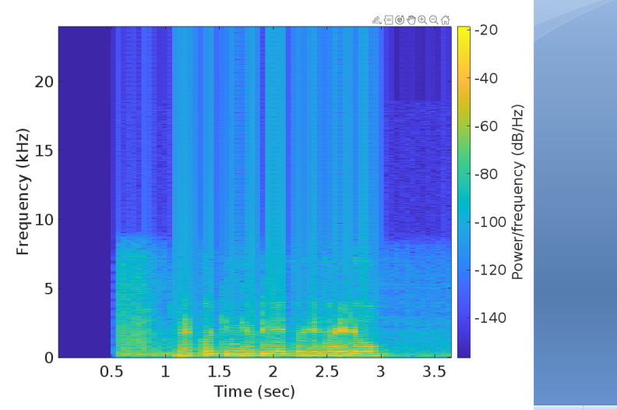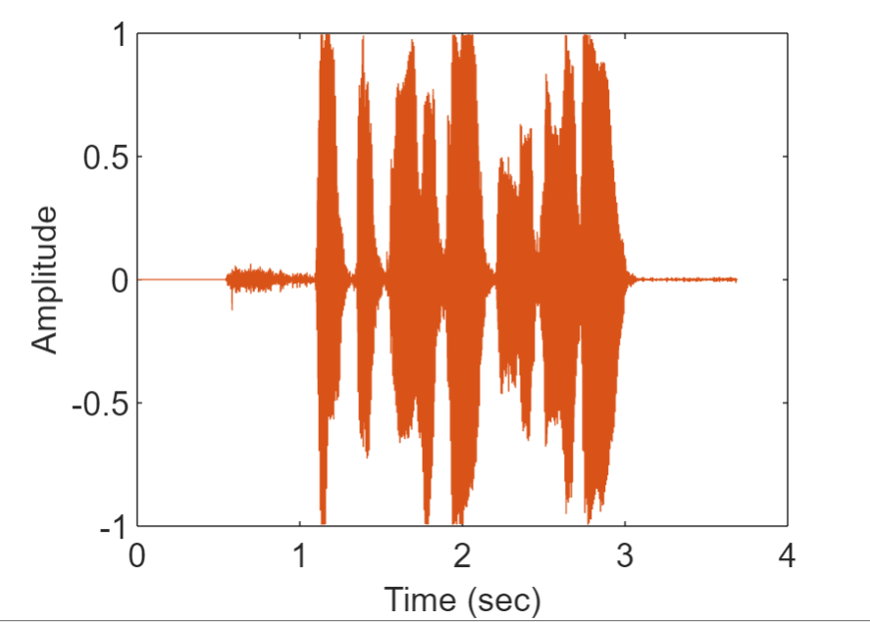

3Q)

1. What are the values of t1, t2, t3, t4, t5, t6 in seconds? (15pt)

Sol)

As given the sample rate is 15000 samples per second so the interval between each sample will be 1/ 15000. So,

t1= 1/17000 sec = 0.0000588235sec

t2= 2/17000 sec = 0.0001176471sec

t3= 3/17000 sec = 0.0001764706sec

t4= 4/17000 sec = 0.0002352941sec

t5= 5/17000 sec = 0.0002941176sec

t6= 6/17000 sec = 0.000352912sec

1. A speaker generates a mixed signal that has two main frequency components (3 kHz and 21 kHz) towards the receiver. How would the receiver pick up this signal? (15pt)

Sol)

The 3KHz signal will be successfully collected and rebuilt back because of the sampling rate of 17000 samples per second. However, due to aliasing, the 21 KHz will appear as 5 KHz to the receiver (21 KHz - 15 KHz), which adds redundancy to the reception.